Weekly Research Report Studio 6

Student name : Zihan Liu

Report date : 6/05/2024

What did you do this week?

*Outline briefly what you did this week and what you achieved.*

Polishing the details including counting GST amount, submit buttons effect message, adding calendar , drop-down window ,User Login Logout buttons, button color change effects, adding designed message box, changing the buttons to adapt theme colors. Etc.

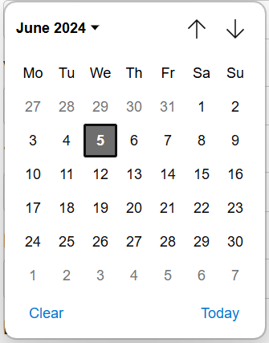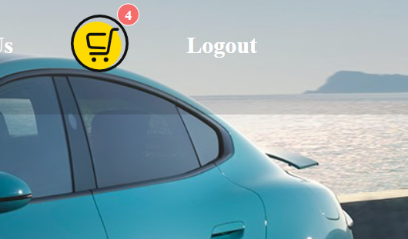

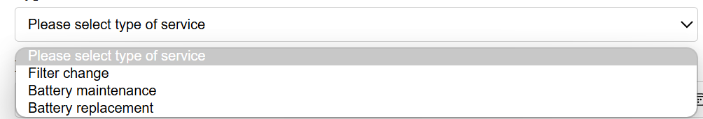 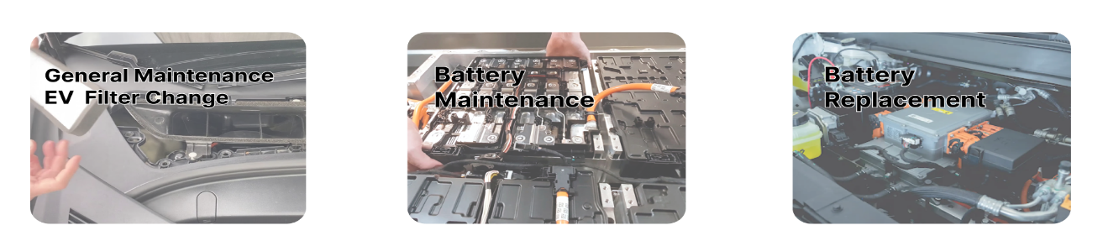(Figma)  
  
  
  
  
  
Made the header and footer consistent for all pages.

Tidied up the database tables and newly added EVservice table

What are you planning to do next week?

*Describe what you plan to do next week and what you want to achieve.*

*Fully tested and to be ready to deliver .*

*Upload the code to the server, configure the domain name to be associated with the server, and make the website accessible*

*Improve evservice booking page UI*

*Keep updating the Trello.*

*Make a clear plan that how to continuous develop the website as it still has a lot of space to improve.*

Do you need help with anything?

*What can your supervisor help you with? Make a list of things we can work on together.*

Could we test it together, I think that will be very helpful, and I might need some guidance for my presentation as well. Thanks